Initial Product Definition and Scrum Team Plan

Submitted by
Team Innovation

Submitted on
December 9, 2025

Team Members
Adam Voss
Cory McCombs
Jacqueline Vo
Richard Sanchez

1. Product Name and Description

The product is named the Attendance Tracking System (ATS). The ATS is a simple, multi-tiered web application designed to facilitate quick and verifiable class attendance logging by students. Its primary purpose is to replace manual attendance checks with an automated, self-service digital method. The system relies entirely on a local data source, specifically an XML file, and deliberately avoids using any external APIs for core functionality. This constrained approach ensures a focused development effort and adherence to a simple architectural pattern. The ultimate goal is to provide the professor with accurate, timestamped records of student presence without complex external database dependencies.

2. Functionality Overview

The Attendance Tracking System focuses on core attendance submission and validation.

- The system presents a simple User Interface (UI) with an input box for the student to enter their name.
- The system uses client-side validation (JavaScript) to ensure the input is not empty and case-sensitive matching (e.g., first letter capitalized) against the stored class list.
- The system validates the submitted name against a local XML database to confirm the student is enrolled.
- Upon successful validation, the system generates a submission timestamp.
- The system persists the attendance record (Student Name + Timestamp) in the XML database file.
- The system will require an initial manual process to load and populate the XML class list from the source data.

3. Overview of Architecture

The Attendance Tracking System will utilize a multi-tiered architecture consisting of three main layers:

- Platform: The application will be deployed as a standard web application accessible via a web browser.
- User Interface (UI): This layer will be built using standard web technologies: HTML for structure and basic styling, and CSS for presentation.
- Business Logic/Validation: This unit will handle data validation and the time-stamping logic. The primary language used here will be JavaScript (client-side for validation) and an appropriate server-side language (e.g., Python, Node.js, or Java, depending on team skills) to manage the database connection and writing process.
- Database: The application will use a local XML-formatted file as the persistent data store. This acts as the database layer.
- Constraints/Patterns: A core constraint is the absence of external APIs. The guiding pattern is a simple separation of concerns between the UI, the business logic, and the local data persistence.

4. Scrum Team Members

Name | Role | Hours/Week | Responsibility | Skillsets
Adam Voss | Developer | 5 | Development | C#
Cory McCombs | Product Owner/Developer | 5 | Responsible for the backlog and value, development | Project Management, Java
Jacqueline Vo | Scrum Master | 5 | Responsible for the process and removing impediments | C#, Python
Richard Sanchez | Developer | 5 | development | C#

5. Virtual Daily Scrum Meetings

- Location: Google Chat
- Time chosen 12:00 PM EST:

6. Final Test Platform

Testing Layer | Chosen Tool(s) | Purpose
Unit Testing | MSTest | To verify the C# backend logic, especially the critical Server-Side Validation Logic (System Story 3), and meet the >=80% code coverage requirement.
Functional UI Testing | Selenium | To automate end-to-end testing of the user interface, verifying the Acceptance Criteria (AC) for all user stories, including the success, error, and accessibility flows.
Manual Testing | Keyboard and Screen Reader | To manually confirm compliance with the strict Usability/UX requirements and WCAG guidelines (User Story 5), verifying proper focus management and ARIA announcements.

7. Screenshot Examples of the Final Test Platform
This is the entry page that will accept either the written name or a selection from the list to submit.
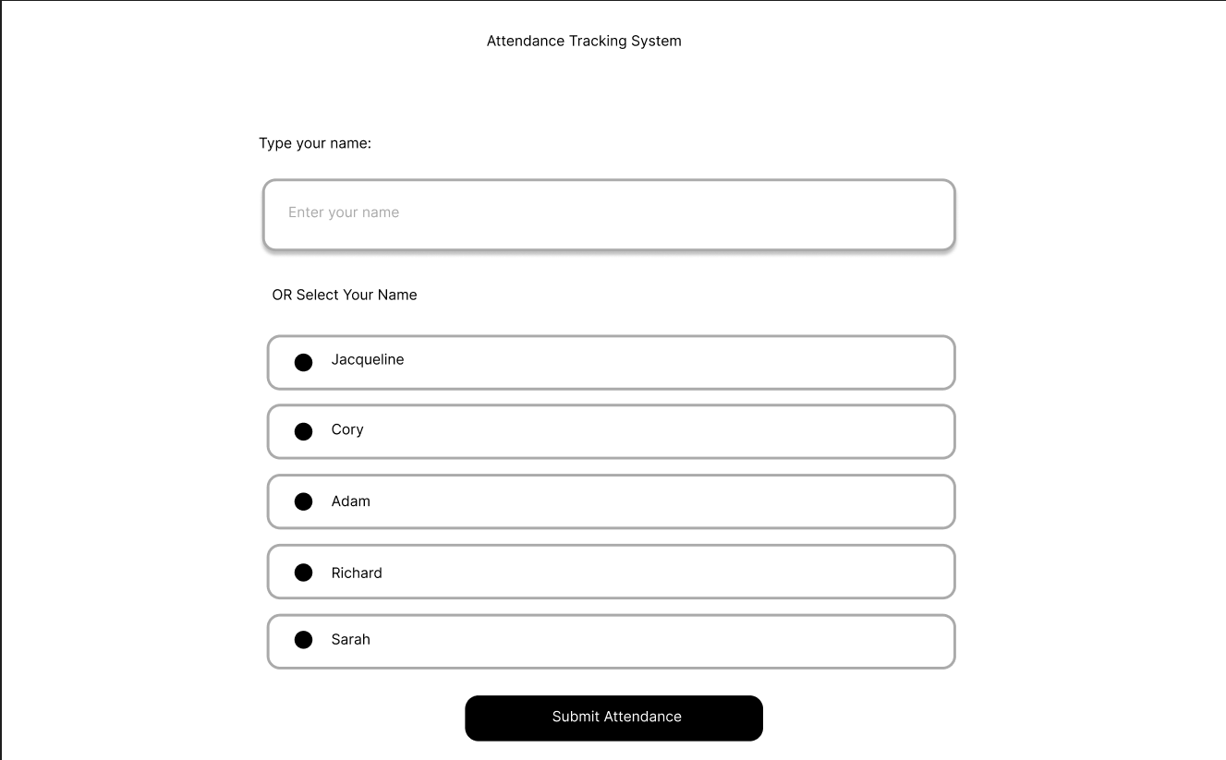

This page is the confirmation page for the attendance getting logged
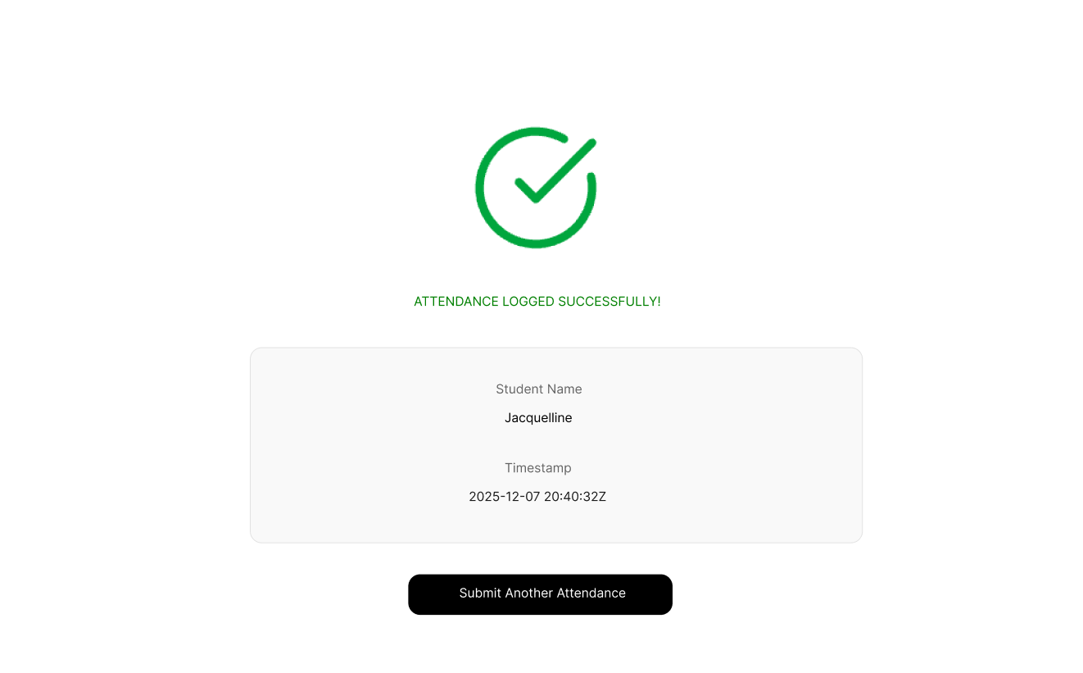
This page represents the error page when the name does not match the list.
